High-Level Programming Languages

💻 What are High-Level Programming Languages?
# Source: AI Source: Provided by: [Data Path: Persons Table -> ID Column: 1, Name_En Column: Motasem Essam] -> From: [Chatgpt (GPT‑5 Mini)] on [12/9/2025]
A high-level language is a type of programming language that is easy for humans to read, write, and understand, because it is closer to human language than to machine code.

📌 Simple definition:
# Source: AI Source: Provided by: [Data Path: Persons Table -> ID Column: 1, Name_En Column: Motasem Essam] -> From: [Chatgpt (GPT‑5 Mini)] on [12/9/2025]
High-Level Language = Human-friendly programming language

🧠 Key idea:
# Source: AI Source: Provided by: [Data Path: Persons Table -> ID Column: 1, Name_En Column: Motasem Essam] -> From: [Chatgpt (GPT‑5 Mini)] on [12/9/2025]
You write code in a simple way → the computer translates it → then executes it

🔍 Characteristics:
# Source: AI Source: Provided by: [Data Path: Persons Table -> ID Column: 1, Name_En Column: Motasem Essam] -> From: [Chatgpt (GPT‑5 Mini)] on [12/9/2025]
- ✅ Easy to read and write
- ✅ Uses English-like words (e.g., if, while, print)
- ✅ Hides complex hardware details
- ✅ Portable (can run on different systems)

⚙️ Compiler

⚙️ What is a Compiler?
# Source: AI Source: Provided by: [Data Path: Persons Table -> ID Column: 1, Name_En Column: Motasem Essam] -> From: [Chatgpt (GPT‑5 Mini)] on [12/9/2025]
A compiler is a program that translates the entire high-level programming code into machine language (binary) all at once before the program runs.

📌 Simple definition:
# Source: AI Source: Provided by: [Data Path: Persons Table -> ID Column: 1, Name_En Column: Motasem Essam] -> From: [Chatgpt (GPT‑5 Mini)] on [12/9/2025]
Compiler = Converts whole code into machine code before execution

🧠 Simple idea:
# Source: AI Source: Provided by: [Data Path: Persons Table -> ID Column: 1, Name_En Column: Motasem Essam] -> From: [Chatgpt (GPT‑5 Mini)] on [12/9/2025]
You write code → compiler translates everything → then you run the program

🔍 How it works:
# Source: AI Source: Provided by: [Data Path: Persons Table -> ID Column: 1, Name_En Column: Motasem Essam] -> From: [Chatgpt (GPT‑5 Mini)] on [12/9/2025]
- You write the full program
- The compiler checks the whole code for errors
- If no errors, it translates it into machine code
- Produces an executable file
- You run that file

🧩 Example:
# Source: AI Source: Provided by: [Data Path: Persons Table -> ID Column: 1, Name_En Column: Motasem Essam] -> From: [Chatgpt (GPT‑5 Mini)] on [12/9/2025]
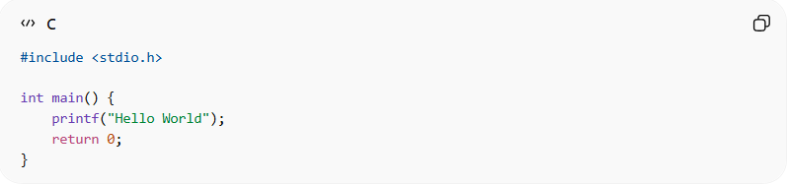
#include <stdio.h>

int main() {
printf("Hello World");
return 0;
}
👉 The compiler converts this into machine code before running it.

🧩 Languages that use compilers:
- C
- C++
- Go
- Rust

🆚 Compiler vs Interpreter
# Source: AI Source: Provided by: [Data Path: Persons Table -> ID Column: 1, Name_En Column: Motasem Essam] -> From: [Chatgpt (GPT‑5 Mini)] on [12/9/2025]
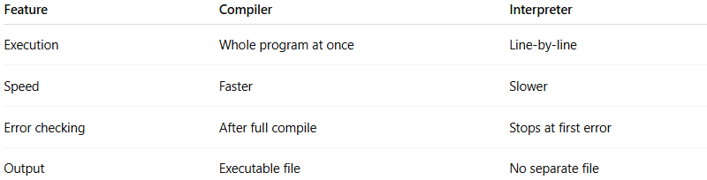
Feature | Compiler | Interpreter
Execution | Whole program at once | Line-by-line
Speed | Faster | Slower
Error checking | After full compile | Stops at first error
Output | Executable file | No separate file

🎯 Key points:
- ⚡ Faster execution after compilation
- 🔍 Detects errors in the whole program
- 📦 Produces an executable file

✅ Summary:
# Source: AI Source: Provided by: [Data Path: Persons Table -> ID Column: 1, Name_En Column: Motasem Essam] -> From: [Chatgpt (GPT‑5 Mini)] on [12/9/2025]
A compiler translates the entire program into machine code before execution, making the program run faster but requiring a full compilation step.

💻 Types of High-Level Programming Languages

🧩 1. Procedural Languages
# Source: AI Source: Provided by: [Data Path: Persons Table -> ID Column: 1, Name_En Column: Motasem Essam] -> From: [Chatgpt (GPT‑5 Mini)] on [12/9/2025]
- Focus on step-by-step instructions
- Code is organized into procedures/functions
- Example: C

🧠 2. Object-Oriented Languages (OOP)
# Source: AI Source: Provided by: [Data Path: Persons Table -> ID Column: 1, Name_En Column: Motasem Essam] -> From: [Chatgpt (GPT‑5 Mini)] on [12/9/2025]
- Based on objects and classes
- Combines data + behavior
- Examples: Java, C++, Python

🔄 3. Functional Languages
# Source: AI Source: Provided by: [Data Path: Persons Table -> ID Column: 1, Name_En Column: Motasem Essam] -> From: [Chatgpt (GPT‑5 Mini)] on [12/9/2025]
- Focus on functions and mathematical logic
- Avoid changing data (no side effects)
- Examples: Haskell, Lisp

⚡ 4. Scripting Languages
# Source: AI Source: Provided by: [Data Path: Persons Table -> ID Column: 1, Name_En Column: Motasem Essam] -> From: [Chatgpt (GPT‑5 Mini)] on [12/9/2025]
- Used for automation and quick tasks
- Usually interpreted
- Examples: JavaScript, Python, PHP

🌐 5. Domain-Specific Languages (DSLs)
# Source: AI Source: Provided by: [Data Path: Persons Table -> ID Column: 1, Name_En Column: Motasem Essam] -> From: [Chatgpt (GPT‑5 Mini)] on [12/9/2025]
- Designed for a specific purpose
- Not general-purpose
- Examples: SQL (databases), HTML (structure), CSS (design)

🧩 Examples:
# Source: AI Source: Provided by: [Data Path: Persons Table -> ID Column: 1, Name_En Column: Motasem Essam] -> From: [Chatgpt (GPT‑5 Mini)] on [12/9/2025]
- Python 🐍
- Java ☕
- C++
- JavaScript 🌐

⚙️ Example:
# Source: AI Source: Provided by: [Data Path: Persons Table -> ID Column: 1, Name_En Column: Motasem Essam] -> From: [Chatgpt (GPT‑5 Mini)] on [12/9/2025]
High-level (Python):
print("Hello World")
Low-level (Machine code):
10101000 11001010 ...
👉 You can see how much easier the high-level version is.

🆚 High-Level vs Low-Level
# Source: AI Source: Provided by: [Data Path: Persons Table -> ID Column: 1, Name_En Column: Motasem Essam] -> From: [Chatgpt (GPT‑5 Mini)] on [12/9/2025]
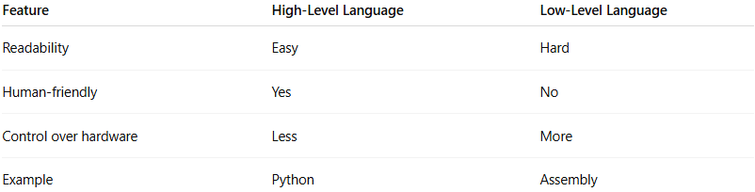
Feature | High-Level Language | Low-Level Language
Readability | Easy | Hard
Human-friendly | Yes | No
Control over hardware | Less | More
Example | Python | Assembly

✅ Summary:
# Source: AI Source: Provided by: [Data Path: Persons Table -> ID Column: 1, Name_En Column: Motasem Essam] -> From: [Chatgpt (GPT‑5 Mini)] on [12/9/2025]
High-level languages make programming easier and faster by allowing humans to write code in a natural, understandable way.

